Industry Project – Research Document
Cluster Platform Investigation for a Kubernetes Observability Lab
Kind vs k3s (via k3d) vs Minikube — Suitability for a Single-Host, Multi-Node DSYS601 Teaching Lab
Report Title | Task 2 – Cluster Platform Investigation: Kind vs k3s vs Minikube for a Single-Host, Multi-Node Teaching Lab
Student | Kabir Singh Thukrai
Student ID | 99281336
Course | BCIS309 – Work Integrated Learning Project
Related Brief Task | Task 2 – Cluster platform investigation (Industry Project Brief, S2 2026)
Industry Supervisor | Abdul Rehman
Academic Supervisor | Bernards Otinpong
Date | 17 September 2026

1. Introduction
This document contains all the information that was required for task 2 of the DSYS601 Kubernetes Observability Lab project. All the investigation and research have been done on suitable cluster platform, single host, multi node cluster. 3 candidate platforms were given for comparison which were Kind vs K3S vs MiniKube, and the comparison has been supported with suitable evidence rather than assumed.
A Kubernetes cluster used for teaching has different priorities from a production cluster. It has to be quick to stand up and tear down between labs and reliable enough that students don’t face any kind of problem while doing the lab. It also needs to be simple enough that a year one DevOps student can do it.

2. Research Objective
To compare Kind, k3s, and MiniKube as candidate platforms for a single-host, multi-node Kubernetes lab for DSYS601, and then recommend the best one to use on the basis of the research and the evidence that I provided.
This research addresses Scope Item 1 and Deliverable 1 of the Industry Project Brief.

3. Evaluation Criteria
The criteria that were used to assess suitability for a teaching lab are given as follows:-
- Ease of installation and setup — Manual steps and configuration which are required to reach a working cluster.
- Multi-node support — ability to represent a control-plane node plus multiple worker nodes on a single host, which the demo application and observability stack depend on.
- Resource requirements — minimum CPU/RAM needed per node, given typical lab VM specifications.
- Startup speed — time to a ready, schedulable cluster
- Stability and reliability — Testing if the cluster comes up consistently across repeated attempts.
- Reproducibility — testing if the cluster can be created and destroyed from a scripted, version-controlled command.

4. Test Environment
The tests were done on an Ubuntu 22.04 LTS virtual machine with 80 GB memory and 11 GB RAM. Docker Engine was installed and relocated to a secondary disk to avoid filling the system volume. Kubectl was also installed before the testing was done. This specification was kept modest so that the comparison reflects platform behaviour under lab-realistic constraints, not best-case conditions.
Host OS | Ubuntu 22.04 LTS (VMware Workstation guest)
vCPUs | 4
RAM | ~11 GB
Container runtime | Docker Engine (installed via get-docker.sh)
kubectl | Installed and verified before testing
Target topology | 1 control-plane node + 2 worker/agent nodes

5. Platform Overviews

5.1 Kind (Kubernetes IN Docker)
Kind runs each cluster node as a Docker container rather than as a virtual machine and is maintained under the Kubernetes SIG umbrella. Because nodes are containers on the existing Docker engine, Kind does not impose a separate hypervisor layer, which keeps the footprint small and the startup fast. Kind made the cluster ready in about 30 seconds.

5.2 k3s (via k3d)
k3s is a CNCF-certified, lightweight Kubernetes distribution packaged as a single binary under 100 MB, which replaces some default components to reduce overhead while remaining a conformant distribution. k3d packages k3s inside Docker containers in the same way Kind packages, which gives it Kind-like startup speed with a smaller resource baseline.

5.3 Minikube
Minikube is the longest-established local Kubernetes tool and aims for close fidelity with a full production cluster, supporting VM-based and container-based drivers, add-ons and a bundled dashboard. It comes with at least 2 CPUs and 2 GB RAM per node, and a multi-node cluster multiplies this requirement across every node, which becomes significant on constrained lab hardware.

6. Testing Methodology
A comparable three-node cluster was created with each tool's default or documented multi-node command, and each cluster was reset and deleted before testing of the next tool.
Commands executed
- Kind: kind create cluster --name test to make sure it was installed successfully
- Minikube: time minikube start --nodes 3 --driver=docker -p minikube-test, repeated with reduced --cpus and --memory flags after initial failures, followed by minikube delete and docker system prune between attempts.
- k3s (via k3d): time k3d cluster create k3s-test --servers 1 --agents 2, followed by kubectl get nodes.
- Cleanup: k3d cluster delete k3s-test and kind delete cluster --name test after each test.

7. Results

7.1 Kind
Kind was installed in a single step with no manual tuning required. The kind create cluster command completed the full sequence — image preparation, node creation, control-plane start-up, CNI and Storage Class installation — automatically.
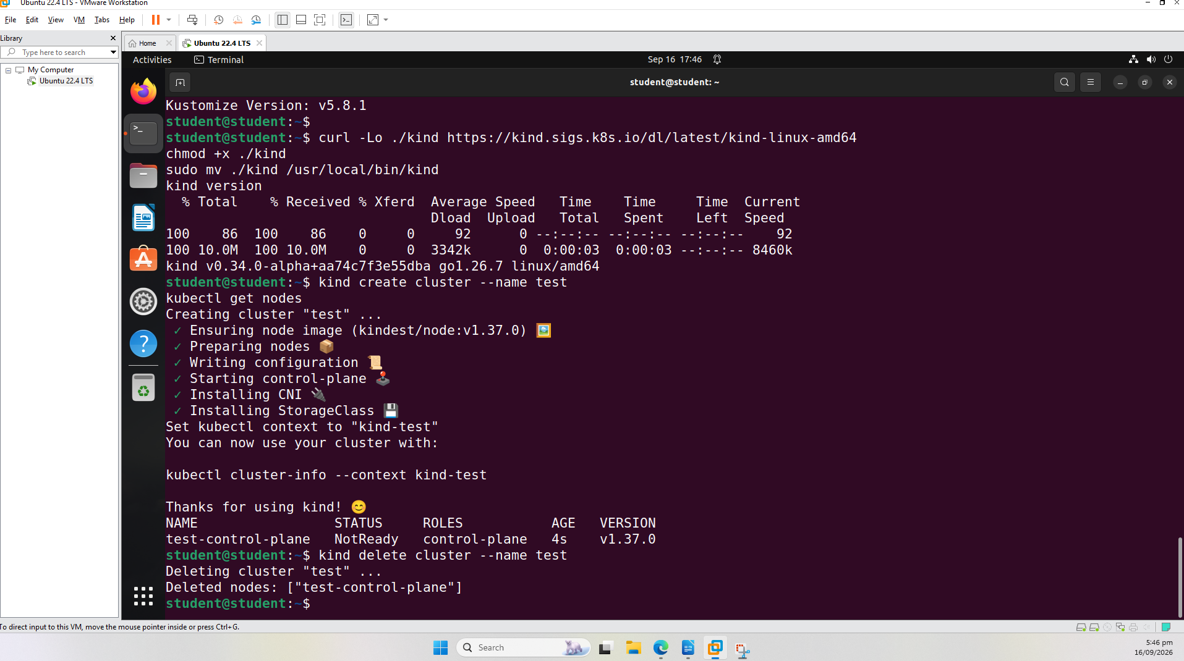
Figure 1 — Kind installation and cluster creation, confirming a working control-plane node on the first attempt.

7.2 Minikube
Minikube failed on its default multi-node invocation and on several subsequent attempts. It required explicit --CPUs and --memory tuning to progress past initial failures, and a second failure mode was encountered. Minikube’s own preflight checks reported a hard requirement of 2 CPUs and approximately 1,900 MB RAM per node, meaning a 3-node cluster required upward of 6 CPUs — more than the 4-CPU test VM provided, and more than a typical shared lab machine could dedicate to a single student's cluster.
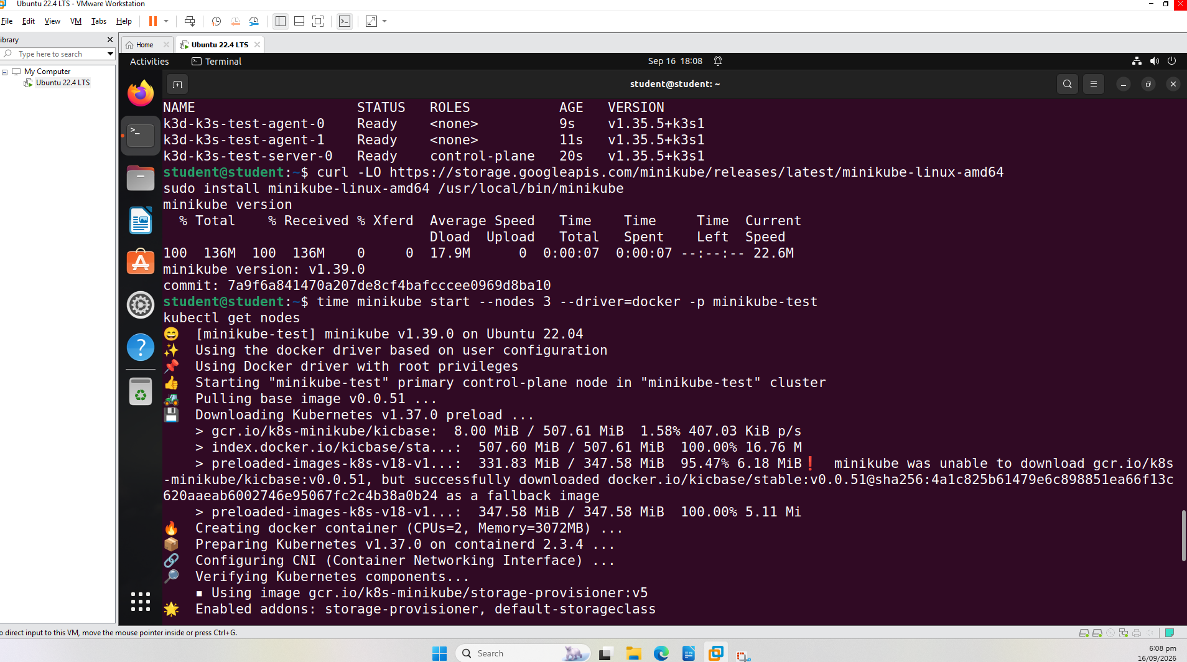
Figure 2 — Minikube installation and a multi-node start attempt; the k3d cluster from the prior test is visible with all three nodes Ready for comparison.

7.3 k3s (via k3d)
k3d created a working 3-node cluster (1 server, 2 agents) on the first attempt, with all nodes reaching Ready status in 23.5 seconds — the fastest of the three platforms tested — and no manual resource tuning was required.

7.4 Summary of Observed Results
Criterion | Kind | Minikube | k3s (k3d)
First-attempt result | Success | Failed repeatedly | Success
Setup effort | Single command | Manual flag tuning required | Single command
Time to Ready (3 nodes) | Not separately timed; consistently fast | Did not complete successfully | 23.5 seconds
Minimum resources observed/required | No enforced minimum; ran comfortably on 4 vCPU / 11 GB | 2 CPU + ~1.9 GB RAM per node (6+ CPU for 3 nodes) | No enforced minimum; ran comfortably alongside existing load
Stability across repeated attempts | No issues | Recurring failures, including an unresolved file-handle limit | Zero errors

8. Comparative Analysis

Kind builds each part of the cluster as a lightweight Docker container instead of a full separate computer (a virtual machine). Because it's just reusing Docker that's already running, there's nothing extra weighing it down so it starts up fast, usually in about 30 seconds, even when you're setting up multiple nodes at once. And even though it's quick and lightweight, it still behaves just like a real Kubernetes setup, which is something other comparisons have found too.

9. Recommendation
Kind is recommended as the cluster platform for the DSYS601 teaching lab, on the following evidence-based grounds:
- It created a working multi-node cluster on the first attempt with no manual tuning, unlike Minikube.
- It ran comfortably within a 4 vCPU / 11 GB test VM, which is representative of realistic lab hardware, whereas Minikube required more CPU than the test VM had available for a 3-node cluster.
- It is scriptable from a single command and a version-controllable configuration file, meeting the brief's reproducibility requirement.
- k3s (via k3d) is noted as a strong secondary option; it matched Kind on raw speed and reliability in this testing and could be revisited if resource constraints on the eventual standing lab host prove tighter than the test VM used here.

10. Conclusion
This investigation compared Kind, Minikube and k3s (via k3d) against criteria relevant to a single-host, multi-node DSYS601 teaching lab, using a controlled, repeatable test on lab-representative hardware. Minikube is not well suited to this use case, while Kind and k3d both performed reliably with minimal setup. Kind is recommended as the primary platform because of its conformance and reproducibility.

